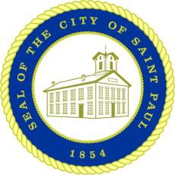Saint Paul Recovery Act Community Reparations Commission

15 West Kellogg Boulevard, 310 City Hall,

Saint Paul, MN 55102-1615 Email: [StPaulReparations@ci.stpaul.mn.us](mailto:StPaulReparations@ci.stpaul.mn.us) Tel: 651-266-8579 | Fax: 651-266-8574

|  |  |
| --- | --- |
| **Commissioners:**  Chair Trahern Crews Vice Chair Khulia Pringle Seph Bloedoorn  Jeremie English Nila Gouldin Idman Ibrahim Nick Khaliq  Ray McCoy  Nick Muhammad Jamila Pickett Carla Robinson | **Meeting Agenda**  **6:00 PM Wednesday, Aug. 28, 2024**  **Rondo Community Library 461 N. Dale** • **Multipurpose Room**   1. Roll Call 2. Labor Acknowledgement 3. Guest Presentation - Robin Rue Simmons, Former Evanston, Illinois Alderwoman    * Visit: [About Robin Rue Simmons – FirstRepair](https://firstrepair.org/robin-rue/) 4. Approval of Previous Meeting Minutes 5. Local Reparations Conference Reflections 6. Draft Workplan Homework Assignments 7. Next meeting 8. Other 9. Adjournment |