HIGHLAND VILLAGE ZONING STUDY

REPORT AND RECOMMENDATIONS

Prepared by the Department of
Planning and Economic Development for the Saint Paul Planning Commission and City Council

February 2011

BACKGROUND
For many years the Highland Business Association (HBA), the Highland District Council (the District Council), business leaders and community members have worked to make Highland Village one of the most successful commercial districts in Saint Paul. The commercial area and spaces that have evolved over these years are a collage of varying building and development styles. This organic growth has served Highland Village well.

Highland Village is now looking to its future and considering the pattern and mix of uses that might be most appropriate as continued development and redevelopment occur. The predominant B2 and B3 zoning currently in place for most of the Highland Village commercial area supports a range of service and retail uses in an variety of building and lot patterns. There is interest in considering whether TN2 zoning in the area might provide for a wider range of mixed uses, as well as a stronger development and design framework that promotes a more traditional “main street” pattern.

In January 2010, the Saint Paul Planning Commission received a formal request from the Highland Park District Council to initiate a zoning study of the Highland Village Commercial Corridor to bring zoning into compliance with neighborhood plans and the community’s vision for the future of Highland Village. This formal request came after the District Council engaged property owners facing Cleveland Avenue and Ford Parkway, the Highland Business Association, and other district residents to gain community consensus around studying the appropriate zoning. The District Council specifically asked the Commission to explore rezoning most of the commercial areas from B2 Community Business and B3 General Business to TN2 Traditional Neighborhood within designated boundaries.

In August 2010, the Planning Commission initiated the Highland Village Zoning Study for the area generally defined as Ford Parkway from Mississippi River Boulevard to Howell Street, and Cleveland Avenue from Hillcrest Avenue to Randolph Avenue.

PLANNING PRECEDENTS
For over 60 years, the Highland Business Association (HBA) has worked to create commerce and develop the Highland Village commercial area. During the past two decades, the HBA has worked in collaboration with the Highland Park District Council to continue to grow this strong commercial district at the heart of the Highland neighborhood. This vision has been regularly and heartily embraced in several plans supported by the community and adopted by the Saint Paul City Council.

The Highland Village Plan from 1984 provided a general land use and urban design framework for the Highland Village commercial area. It envisioned the district as a commercial center with a strong distinctive image that was pedestrian-friendly and compatible with adjacent residential property. The plan addressed the physical appearance of commercial buildings with new design standards, and was especially concerned with the pedestrian environment throughout the commercial area. Site design objectives included: providing continuity throughout the Village by using common elements, such as light standards, fences and plant materials; defining spaces and edges clearly and attractively; and subordinating cars to people, separating and buffering cars from pedestrians as much as possible.

The District 15 Highland Park Neighborhood Plan Summary, adopted as an addendum to the Saint Paul Comprehensive Plan in 2007, reinforces the vision of Highland Village as a vibrant, mixed-use district. “Through the implementation of the plan the community strives to incorporate a mix of uses and a pedestrian friendly street environment in commercial areas.” The plan also states the desire to rezone portions of the Village to TN2 to support mixed-use development and promote building and streetscape design that reinforce the public realm and contribute to a safe, attractive pedestrian environment.

The Land Use Plan, adopted in 2009 by the City Council as a chapter of the Saint Paul Comprehensive Plan, designates Highland Village as a Mixed-use Corridor. Mixed-use corridors are thoroughfares through the city that are served by public transit (or could be in the future). They include areas where two or more uses are located, or could be located, such as: residential, commercial, retail, office, small scale industry, institutional, and open space.

HIGHLAND VILLAGE TODAY
Existing Land Use
Today, Highland Village is predominantly a commercial district along two main corridors, Ford Parkway and Cleveland Avenue. Residential uses at the edges of the commercial corridors consist primarily of multi-family housing. The adjacent neighborhood fabric is predominantly single-family residential.

Existing Zoning
Most of the study area is currently zoned B2 Community Business, B3 General Business, and RM2 Medium-Density, Multiple-Family Residential. A few parcels are zoned R4 One-Family Residential Districts, I1 Light Industrial, OS Office Service, and VP Vehicular Parking. Map A (page 5) shows existing zoning for study parcels.

The B2 district is intended to serve the needs of a consumer population larger than that served by the “local business district,” and is generally characterized by a cluster of establishments generating large volumes of vehicular and pedestrian traffic.
- In the study area, parcels zoned B2 include restaurants, medical clinics and offices, general retail (including grocery), professional services offices, personal services, and parking.
- B2-zoned parcels comprise 53% of all parcels in the study area.

The B3 district is intended to accommodate businesses more diversified than those in the B1 and B2 districts along major traffic arteries or adjacent to community business districts.
- In the study area, the four (4) parcels zoned B3 are used for a fast-food restaurant, an office building, and a medical clinic.
- B3-zoned parcels comprise 5% of all parcels in the study area.

The RM2 district is intended to provide for more extensive areas of multiple-family residential development and a variety of congregate living arrangements, as well as uses that serve the needs of the multiple-family residential districts. RM2 zoning is typically located along and/or near major thoroughfares and transit corridors.
- In the study area, parcels zoned RM2 are mostly condos, apartments and townhomes.
- RM2-zoned parcels comprise 32% of all parcels in the study area.

The R4 one-family residential district provides for an environment of predominantly low-density, one-family dwellings along with civic and institutional uses, public services and utilities that serve the residents in the districts. Because of their residential nature, these districts are not intended for more intensive uses such as small conference centers, private retreat centers and reception houses.
- There are two (2) large parcels zoned R4 in the study area -- the Hillcrest Community Center and the adjacent parking lot and ball fields.
- There is one (1) split-zoned parcel with a portion zoned R4. This portion is a berm used to buffer the VP zoned parking lot from adjacent residential.
- R4- zoned parcels comprise 2% of all parcels in the study area.

The I1 district is intended to accommodate wholesale, warehouse and industrial operations whose external effects are restricted to the area of the district and are not detrimental to surrounding districts.
- The four (4) I1-zoned parcels in the study area are on the western end of Ford Parkway. One parcel contains the Liquor Village store, two an auto-specialty store and its parking lot, and the other the Lund’s-anchored shopping center.
- I1-zoned parcels comprise 4% of all parcels in the study area.

The OS district is intended to accommodate various types of office and service uses performing administrative, professional and personal services and to serve as a transitional use between more intensive uses of land such as major thoroughfares or commercial districts and the less intensive uses of land such as one-family residential.
- The three (3) OS-zoned parcels are on Cleveland Avenue, surrounded by RM2-zoned property. Two of the parcels are located at the end of a block that contains B2 and RM2-zoned parcels, and the other OS-zoned parcel is in between two RM2 zoned parcels.
- OS-zoned parcels comprise 3% of all parcels in the study area.

The VP district provides for off-street parking facilities incidental to a principal use.
- In the study area, the one (1) parcel zoned VP is used as parking for Pinehurst Bank.
- VP-zoned parcels comprise less than 1% of all parcels in the study area.

Proposed Zoning

1. Staff believes that the appropriate zoning for most of the parcels in the
study area is TN2 Traditional Neighborhood. Staff recommends that 58 of the 84 parcels studied be rezoned to TN2. The TN2 traditional neighborhood district is designed for use in existing or potential pedestrian and transit nodes. Its intent is to foster and support compact, pedestrian-oriented commercial and residential development that, in turn, can support and increase transit usage. It encourages, but does not require, a variety of uses and housing types, with careful attention to the amount and placement of parking and transitions to adjacent residential neighborhoods.

TN2 is consistent with the Highland Village Plan, the District 15 Highland Park Neighborhood Plan Summary, and the Land Use Plan of the Saint Paul Comprehensive Plan. The shared planning and zoning goals of mixed-use, pedestrian-friendly and transit supportive development make TN2 an excellent fit for Highland Village. Map B (page 10) and Attachment A (pages 11 and 12) show proposed zoning.

In addition, TN2 zoning offers the following benefits:
- New development must comply with design standards that will maintain and strengthen the pedestrian-oriented, “Main Street” character of the neighborhood.
- The flexibility of the zone makes it easier to mix commercial and residential uses on lots within district, providing a broader range of housing types than permitted under conventional business district zoning.
- The permitted land uses, scale and density in TN2 are consistent with existing development and supportive of transit.

- Staff recommend that 621 Cleveland, currently zoned OS, be rezoned to
RM2. This block and the subsequent blocks north of this parcel are all currently zoned RM2. The pattern of development on this portion of Cleveland Avenue is heavily residential and rezoning the parcel would provide consistency with this area. If this parcel is rezoned, the current office use could remain, but would become non-conforming. This would be the only non-conforming use created under the recommended zoning changes in the Highland Village Study Area.

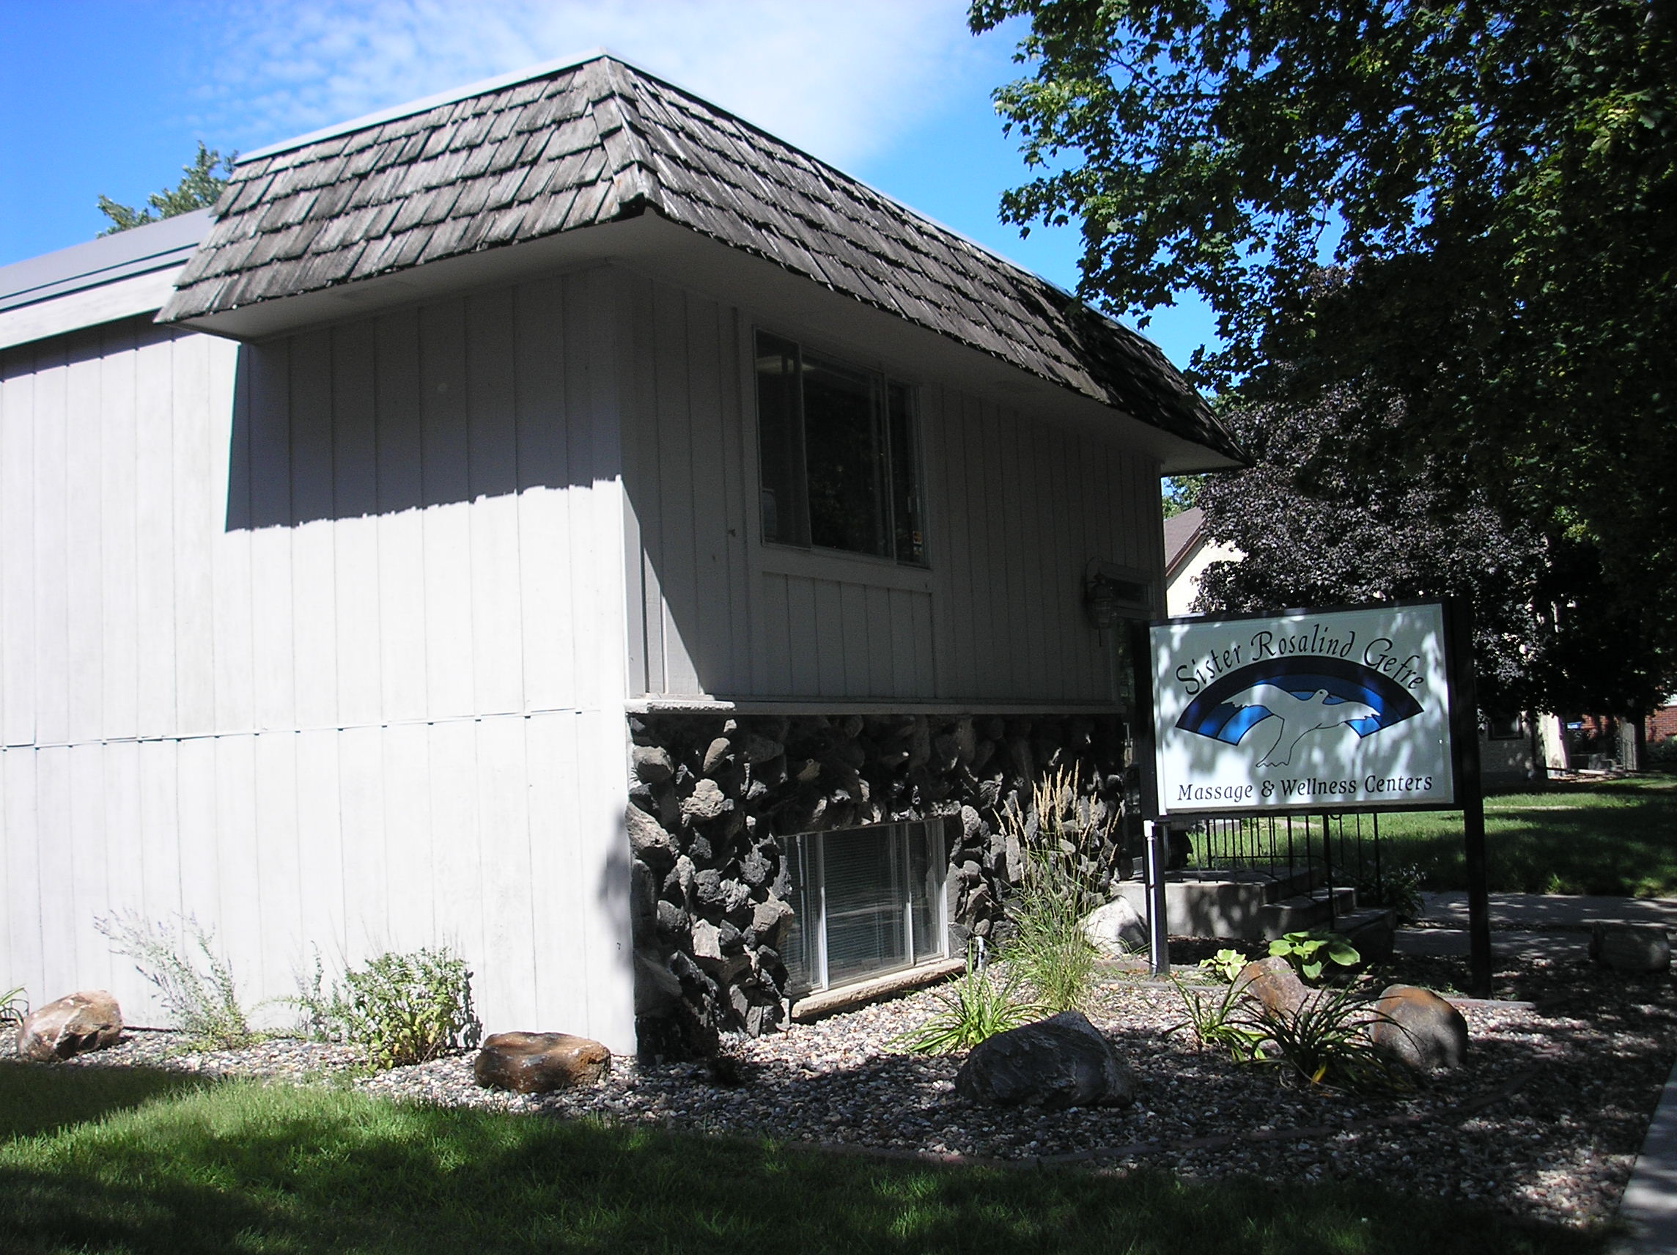

- Staff recommend that 2269 Ford Parkway (Firestone), currently zoned I1, be rezoned to B2. The District has expressed a strong concern over losing auto specialty services. Rezoning this parcel from I1 to B2 would allow this use to remain as a conditional use in the district, while making the parcel more consistent with the use and lot standards in the area.

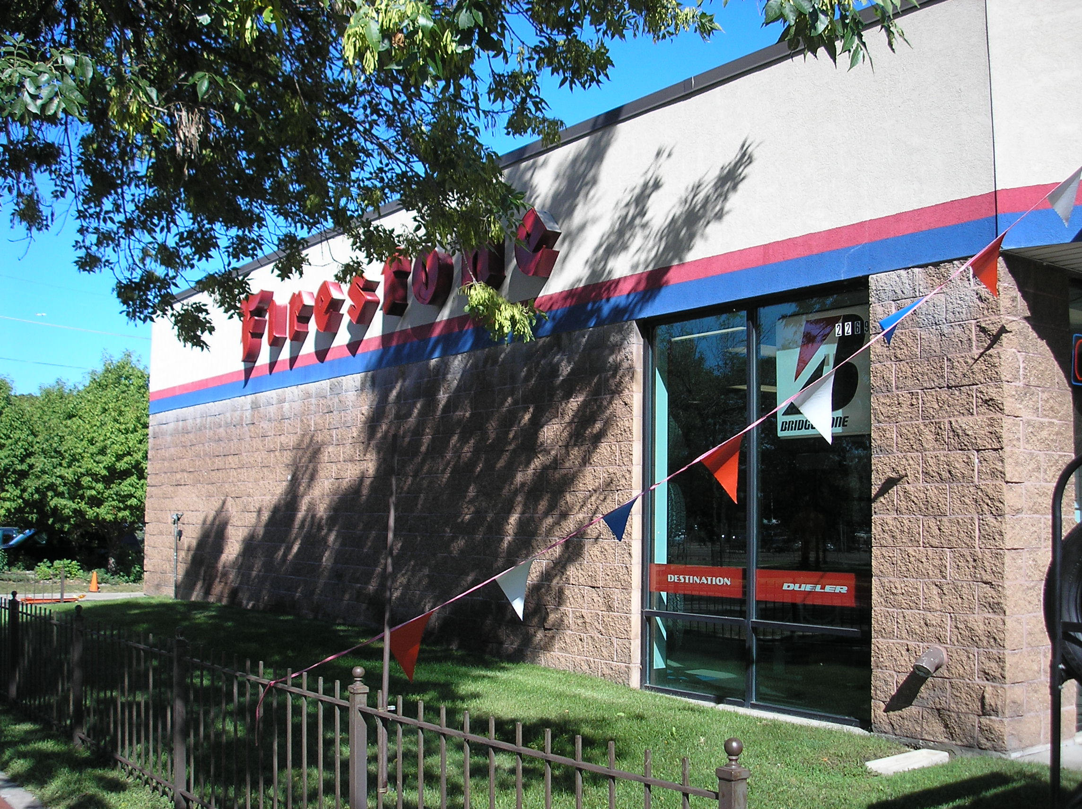

There are a few cases where no rezoning is recommended.

- The eight (8) eastern most parcels on Ford Parkway and the 15 northern most parcels on Cleveland Avenue, not including the restaurant, Luci Ancora, are recommended to remain zoned RM2 and OS for the following reasons:
a. They are solidly residential uses and permitted under RM2.
b. RM2 is an appropriate zone adjacent to TN2.
c. There is no intention to establish commercial uses in the residential units, which would be facilitated by TN2 zoning.

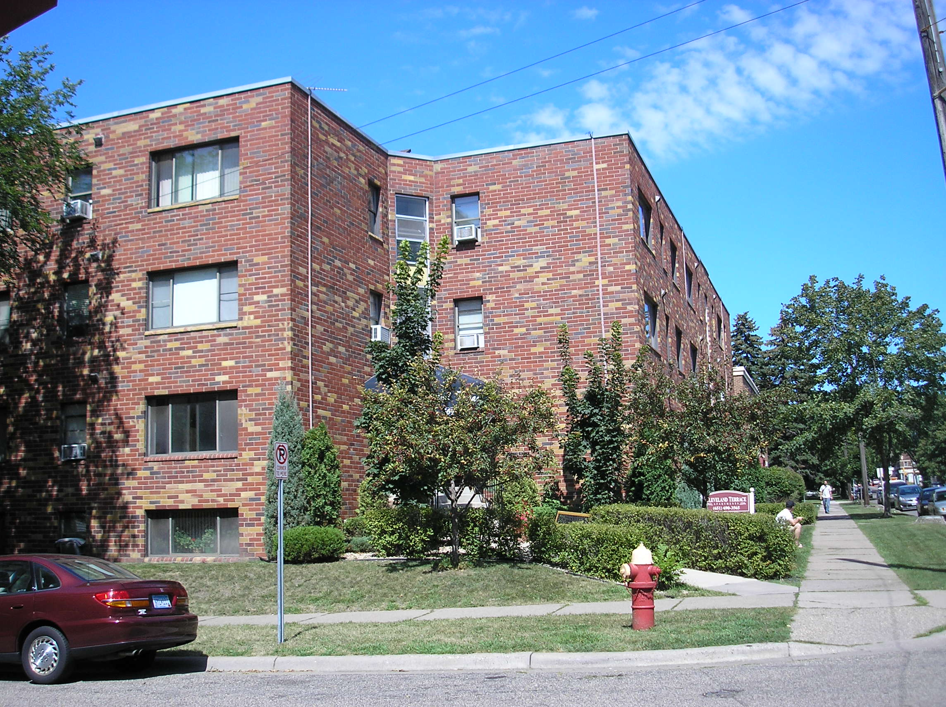

- Pinehurst Bank at 757 Cleveland Avenue South is a split-zoned parcel. It is currently zoned B2, VP, and R4. The building is located on the portion of the parcel zoned B2. Behind the building is a parking lot which is currently zoned VP, and behind that is a small portion of the parcel that is developed as a berm to provide a visual buffer between the parking lot and the adjacent residential lot, which is currently zoned R4. Staff recommend that the portion of the lot zoned B2 be rezoned to TN2, and the portions of the parcel zoned VP and R4 remain as they are.

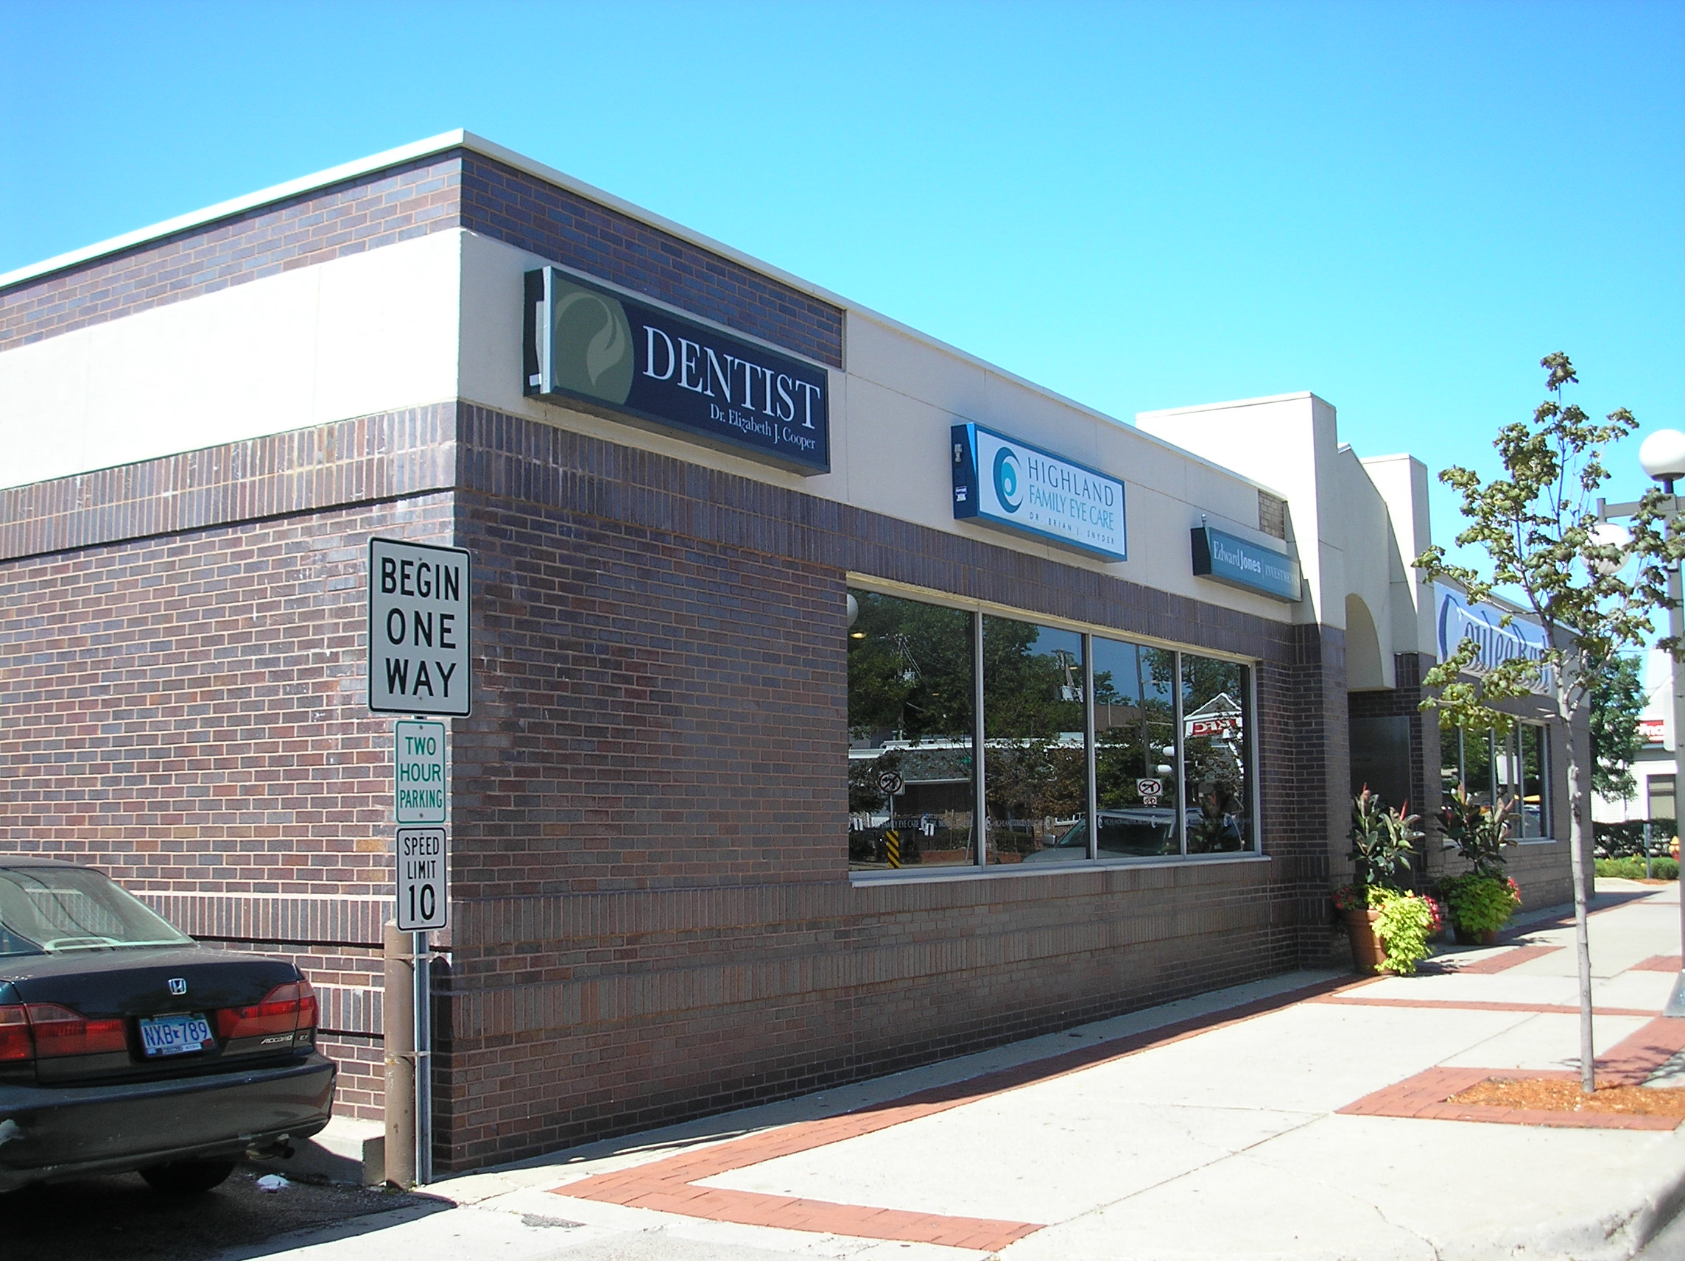

- National Tire and Battery (formerly Tires Plus) at 2185 Ford Parkway, is currently zoned B2. Retaining B2 zoning would allow auto convenience, auto service stations, and auto specialty uses to establish on this parcel as a conditional use, which has been the expressed desire of the community. B2 zoning would be consistent with the Firestone parcel as well.

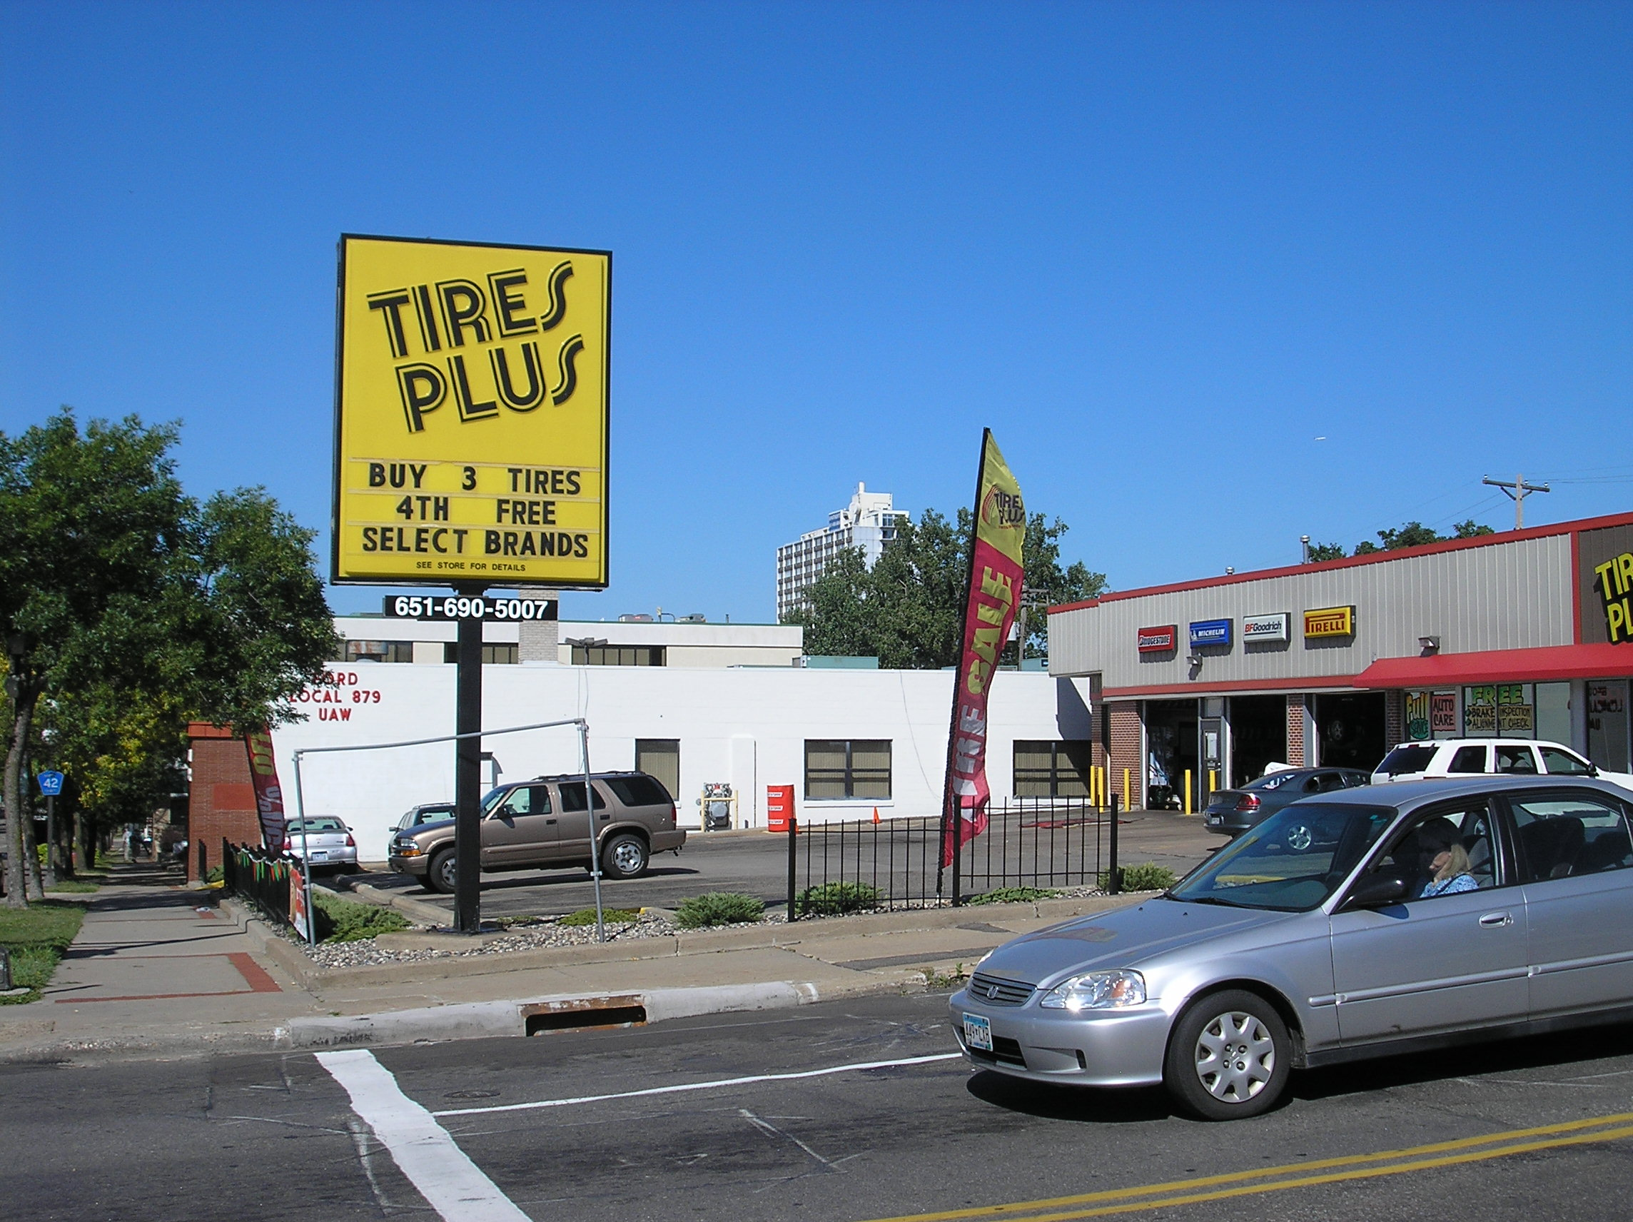

Timeline of Meetings

August 15, 2010 – PED staff presented to District 15 Community Development Committee (CDC). They provided an overview of what a zoning study entails and discussed TN zoning. The comprehensive TN and Central Corridor zoning studies were also discussed as context.

October 14, 2010 – PED staff presented to the Highland Business Association.
They provided an overview of the Highland Village zoning study, TN zoning, and preliminary findings and recommendations. There were about 12 people in attendance. The group felt generally comfortable with the study and preliminary recommendations, with the primary concern being the creation of non-conforming uses at the two auto specialty businesses if they were rezoned to TN2.

November 2, 2010 – PED staff presented to the District 15 Community Development Committee (CDC), providing an overview of the Highland Village zoning study preliminary findings and recommendations.

November 15, 2010 – PED staff presented to property owners in the study area, providing an overview of the Highland Village zoning study, TN zoning, and preliminary findings and recommendations. Four owners attended. (Staff mailed in invitation to all study area property owners two weeks prior to the meeting. Some owners who were unable to attend, called and discussed questions over the phone or attended the community meeting on November 16th.) The attendees felt comfortable with the study and preliminary recommendations, with the primary concern being the creation of non-conforming uses at the two auto specialty businesses if they were rezoned to TN2.

November 16, 2010 – PED staff presented at a public meeting hosted by the District 15 Planning Council. Staff provided an overview of the Highland Village zoning study, TN zoning, and preliminary findings and recommendations. About 20 people attended. The group felt generally comfortable with the study and preliminary recommendations, with some concern about the creation of non-conforming uses at the two auto specialty businesses if they were rezoned to TN2.

December 8, 2010- Neighborhood Planning Committee met and discussed the Highland Village Zoning Study findings and recommendations report. The report was recommended to the Planning Commission to set a date for a public hearing.

December 17, 2010- Planning Commission set public hearing for January 21, 2011.

January 21, 2011- Planning Commission held a public hearing on the Highland Village Zoning Study recommendations.

February 9, 2011 - Neighborhood Planning Committee considered the public hearing comments and recommended that the Planning Commission forward the proposed rezoning of properties to the City Council for review and adoption.

February 18, 2011 – Planning Commission…

