City Hall Conference Rooms

Resource Scheduler User Guide
Resource Scheduler version 11.0

Contents
Overview 3
General Guidelines 3
Logging into Resource Scheduler 3
New & Updated in Resource Scheduler 11.0 3
Creating Reservations 3
Using the Reservation Wizard: 3
Using Daily Planner View 8
Using Quick Reserve 10
Editing a Reservation 12
To modify a reservation: 12
To copy a reservation: 13
To delete a reservation: 14
Making a Reservation Recurring 15
Managing Conflicts: 16
Requesting Catering and Equipment 18
Adding More Information to a Reservation 22
Flagging a Reservation for Follow Up 22
On Behalf Of: 22
Adding Resources 23
Other Features 24
Search Reservations 24
Display Resource Availability 24
Reports 24
Setting Personal Defaults 25

Overview
Resource Scheduler is a web-based single source system used to reserve rooms and equipment for City Hall Conference Rooms.

General Guidelines
All required fields must be completed for every reservation. Any reservation without these will be auto-deleted by the system.

Logging into Resource Scheduler
This is the link to Resource Scheduler: https://company.resourcescheduler.net/resourcescheduler
Clicking on this link will launch your browser and open to the Resource Scheduler Home Page.
Notes:
- Pop-ups must be allowed in the browser for the Resource Scheduler site.
- Please use the links and buttons on pages to move between pages rather than using the browser “back” button.
- For best results, set Internet Explorer to check for newer versions of stored pages “every time I visit the webpage”.

Creating Reservations

Using the Reservation Wizard:
Reservation Wizard searches for available rooms based on several filters. When choosing a recurring pattern for a meeting, the results show only those available for every instance of the pattern. This avoids conflicts that would need to be resolved. Reservation Wizard also provides an easy way to reserve more than one room for a meeting.
- Click Reservation Wizard in the Toolbar or the Quick Links drop-down to be guided through a step-by-step process.
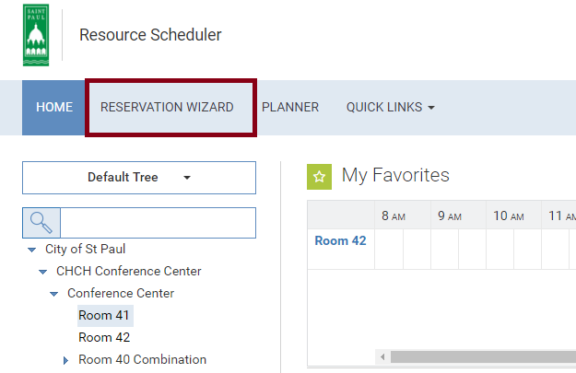
- Use the wizard to set the criteria for the search.
- The first drop-down sets the location(s). Select one or multiple locations, or select All. Specific locations can be clicked in the list, and the header of the drop-down will reflect the number selected.
- If a single location is selected, one or more groups can be selected in the next column. Specific groups can also be selected.
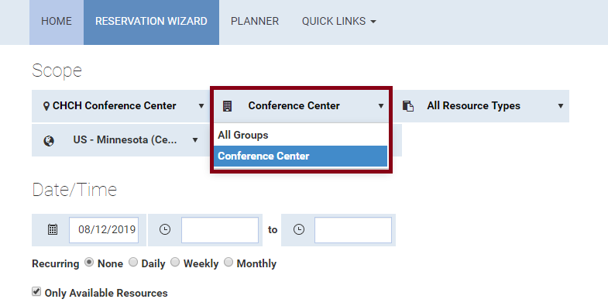

- There may be an option to select the Timezone for Reservation.
- Use the Resource Type to choose one or more types of spaces for the search. Select All for all types.
- Enter Capacity to find a room large enough for the meeting, if appropriate.
- If specific amenities are needed, use the Filter to select them.
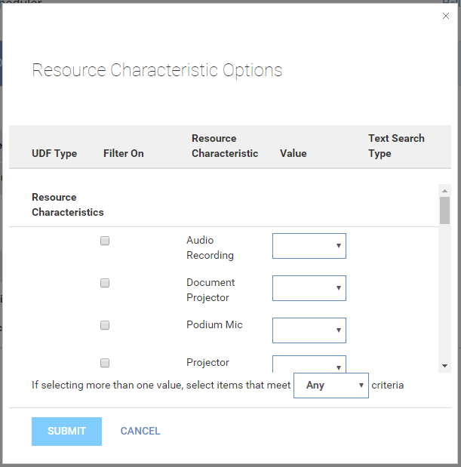
- Specify the Date, Start and End times. 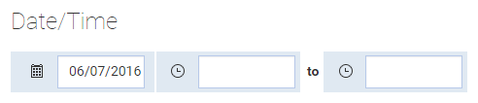
- To only show spaces available at that day and time, check the Only Available Resources box. If a recurring pattern is chosen, only spaces available for every instance of the series will be shown.
- Click on Next to return the results that match your criteria.
- Your meeting time will be highlighted in the results grid. Other meetings appear as colored blocks.
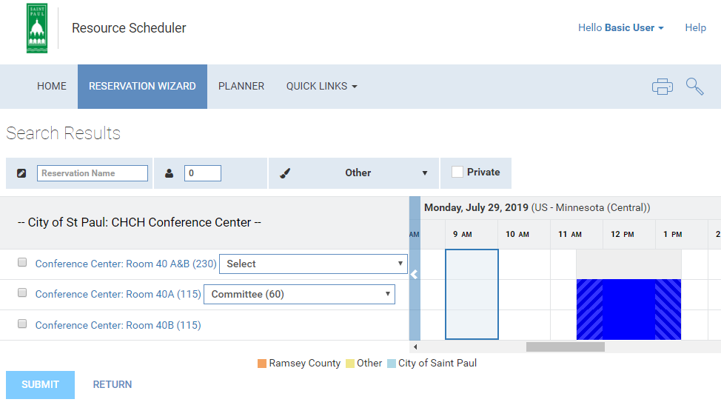

- To view details about a room or space, click on its name in the list.
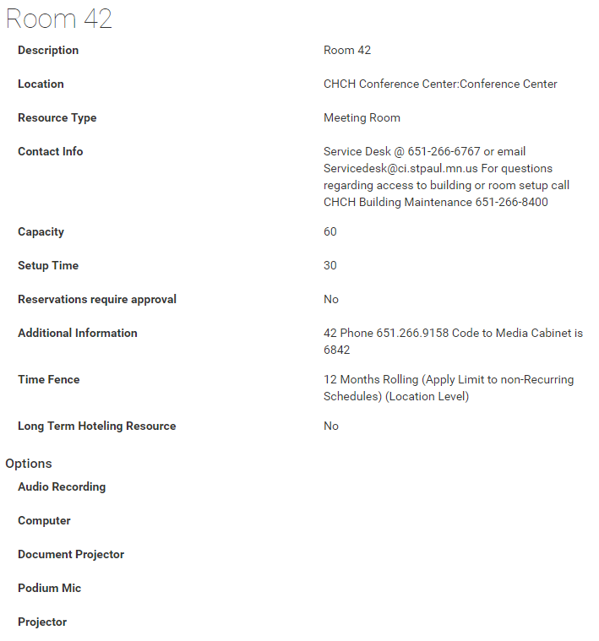
- Numbers in parentheses indicate the max capacity for the room.
- View meeting details by hovering your cursor over other events.
- Type the Reservation Name in the field provided.
- Select the Status from the drop-down menu.
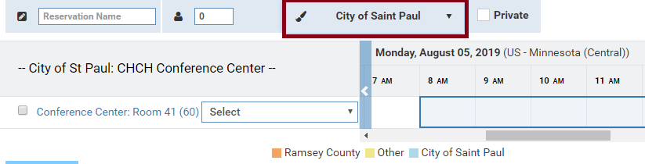
- Check the box for the room(s) you want to reserve, choose a setup style if applicable, and click Submit at the bottom of the page.
- Click Edit to complete the required fields, add services or include other details. The Reservation Details page will open. Click Finished if nothing needs to be added.
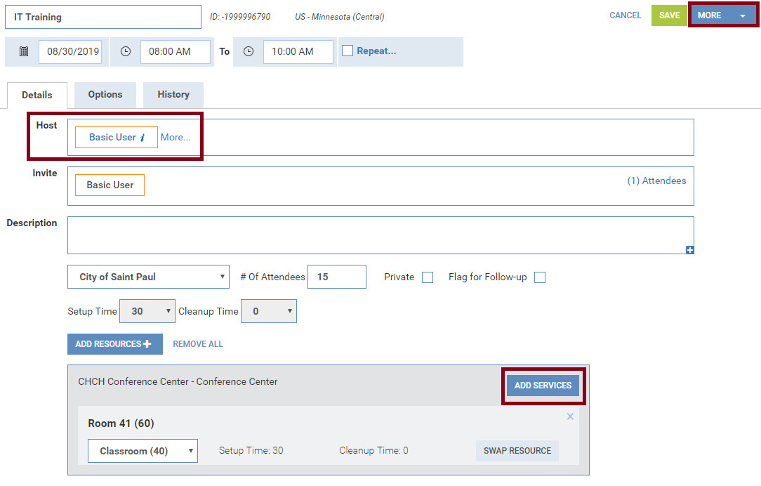
- To assign this meeting to another user as meeting host, use the Host section, clicking More to add details. See the Adding More Information to a Reservation section for more information.
- Setup and cleanup times can be adjusted by Scheduling Administrators.
- To add catering or other services, click the Add Services button. See the Requesting Equipment section for more details.
- To e-mail information regarding this reservation, click More at the top right and choose the Email options.
- Click the Submit button at the bottom of the page when finished.
- Back at the confirmation page, click Finished to be returned to Reservation Wizard to continue making reservations.

Using Daily Planner View
Daily Planner View provides the ability to view, manage and create reservations across one location for a single day. To view it, click on the Planner button in the tool bar.
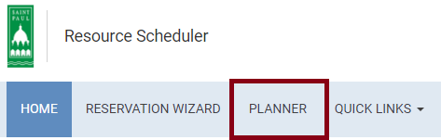
- Choose the Scope for the search. Specific Locations and/or Resource Types can now be selected. Most users prefer not to limit the Resource Type or Capacity when using Daily Planner View. Select the Date.
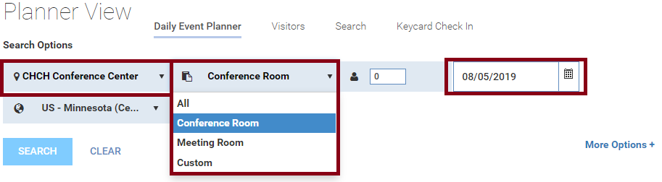
- Click the More Options link to see additional filters. If desired, choose the Display Settings for information to be displayed in the grid. Title is the most common option. Most other filters will not apply to your location. Click Less Options to collapse the filters again.
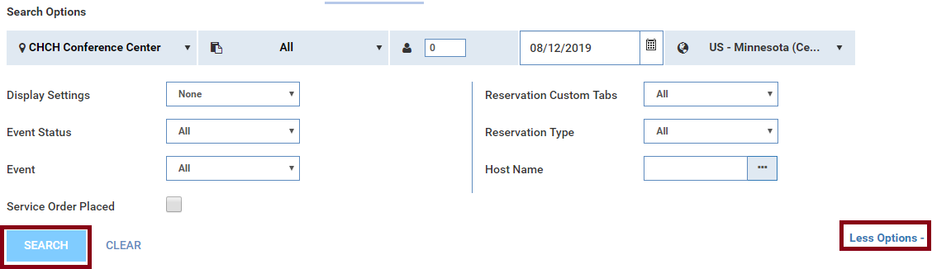
- Click the Search Button.
- The search criteria can be collapsed by clicking on the Hide link in the upper right hand corner. If the search was for today, a Red Line indicates the current time. Existing reservations appear as colored blocks in the grid.
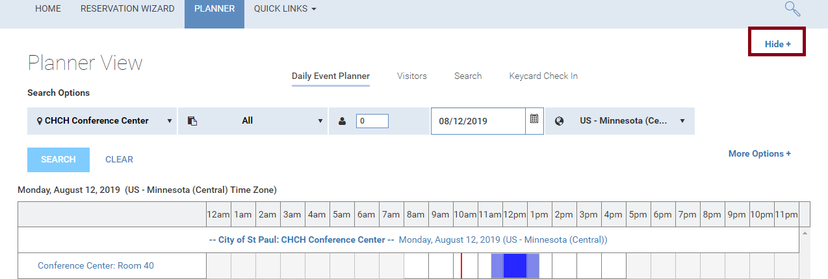
- Symbols may appear by some reservations. They include:
  - designates a recurring reservation.
  - indicates that the meeting includes an equipment request.

- Hovering over an existing reservation displays a pop-up window with links to Edit, Details and Delete. You can only make changes if you created a reservation or are a Scheduling Administrator for that room.
  - Edit opens a Quick Reserve-style window for quick changes.
  - Details opens the Reservation Details page for more advanced editing.
  - Delete allows you to cancel the reservation.
- Click on an available time in the grid to open a Quick Reserve template, which is similar to the Quick Reserve in Schedule View (see the Using Quick Reserve section for details).

Using Quick Reserve
Use Quick Reserve to create a reservation from the Schedule View. This method is especially easy when you know what space you want to reserve. Clicking on a group folder in the Navigation Tree (on the left side of the screen) will open this view. Clicking on a single room in the Tree will open its Schedule View.
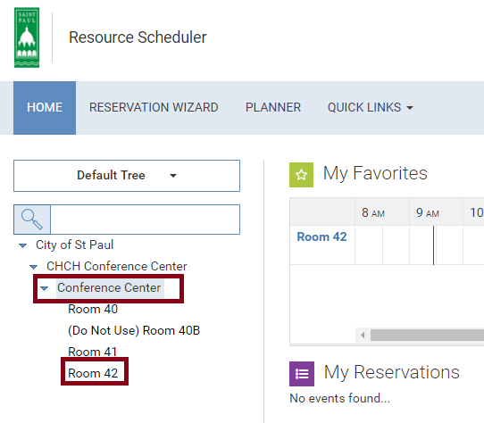
To change dates for the Schedule View, tabs at the top provide Day, Week, Month and Timeline views which can be scrolled by using the arrows. Click the date(s) to open a date-picker calendar.
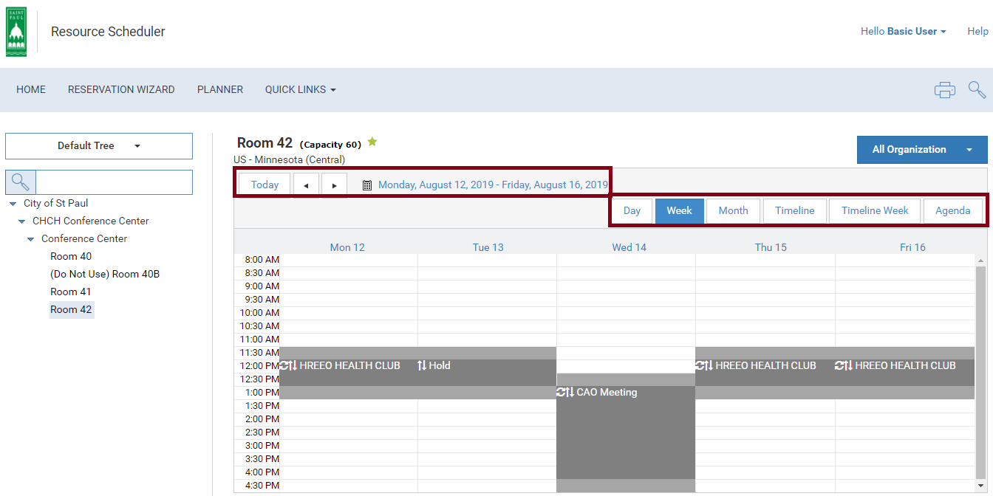
- When viewing the schedule, click on an open block of time. This will open the Quick Reserve window.
- Enter the Reservation Title, # Of Attendees, Setup (if available), Date, Start and End times for the reservation. If the reservation is for another Resource Scheduler user, begin typing their name in the Requested For field. After 3 or 4 characters, a drop-down list of options will appear. Select the correct user. Since the system already recognizes you as the creator of the reservation, it will not display your user profile in the choices.
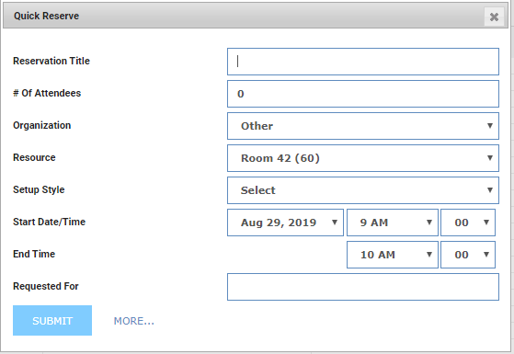
- Click Submit to complete the reservation. Click More to open the details page to add any other information such as catering or AV requests.
- Add additional details as needed. See the Using the Reservation Wizard and Adding More Information to a Reservation sections for more information.
- When finished entering details, click Save, which will return you to the Calendar View.

Editing a Reservation
To review information about a reservation or update the reservation, click on the Reservation Title in the Schedule View, My Reservations, My Flagged Reservations or in any search results.

To modify a reservation:
- Click on the link to the reservation you are interested in.
- In the Reservation Details page, make necessary changes to the reservation. The meeting host and any attendees will be notified of the change.
- If a date or time change results in a conflict, a warning prompt will appear. Read the prompt and resolve the conflict. See the Managing Conflicts section for details.
- Click Save.

To copy a reservation:
NOTE: Recurring reservations and reservations that were created through the Outlook interface cannot be copied.
- Click on the link to the reservation you are interested in. In the Reservation Details page, click the More button at the top right. Select the Copy option. 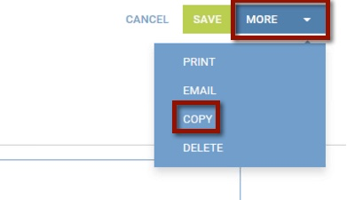
- Depending on the reservation, you will be given options of other details to copy, including Attendees, Services, etc.
- Click Copy at the bottom left. 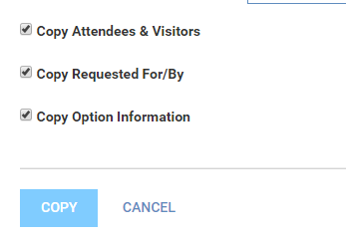
- Resolve any conflicts that occur. See the Managing Conflicts section for details.

To delete a reservation:
There are two ways of cancelling a reservation:
From My Reservations:
- CHANGED: Click on the X at the top right of the box for the reservation you wish to cancel.
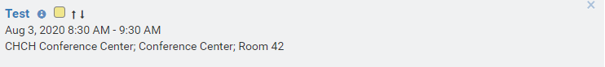
- Click OK to confirm.
From within the Reservation Details page:
- Click on the link to the reservation you are interested in cancelling.
- In the Reservation Details page, click the More button. Select the Delete option. 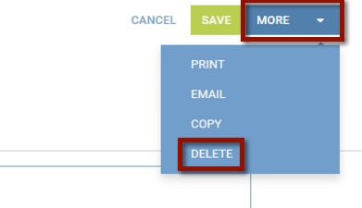
- Click OK to confirm.

Making a Reservation Recurring
In the Reservation Details page, select the Repeat checkbox and set the recurrence pattern. 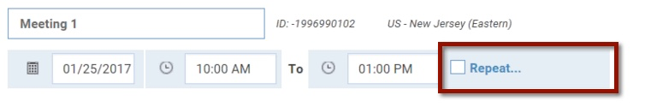
Use the Ad Hoc feature to add days which do not fit one of the standard patterns. To edit an existing series, click the Options link next to the Repeat checkbox. Resolve any conflicts that occur – no room is reserved for those dates. 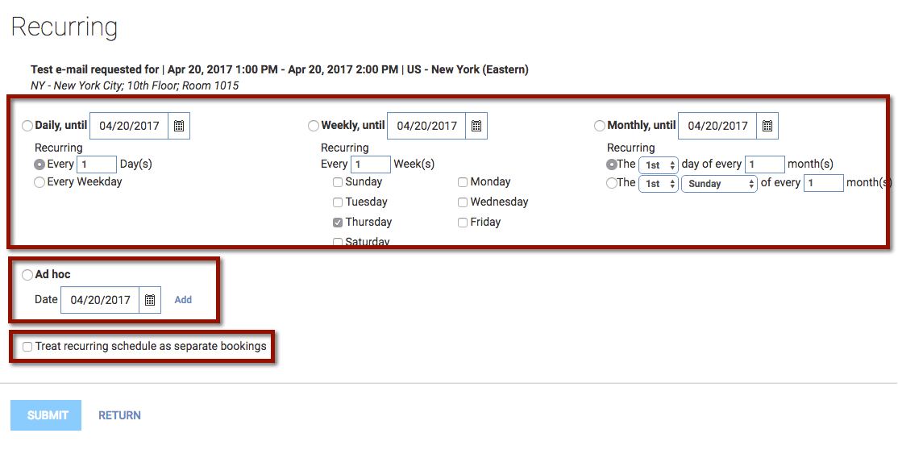
NOTE: It is recommended to not use the checkbox for “treat as separate bookings”. This will create each instance as a separate reservation, and will require each to be edited separately rather than as a series.
When managing recurring reservations, there will be an option to make a change to a single instance or that instance and all future. 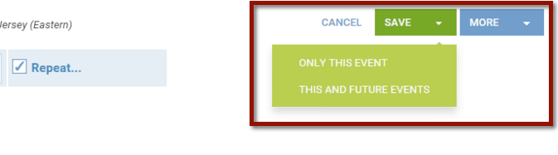
The same applies to canceling reservations. There will be an option to delete the single event or the rest of the series. 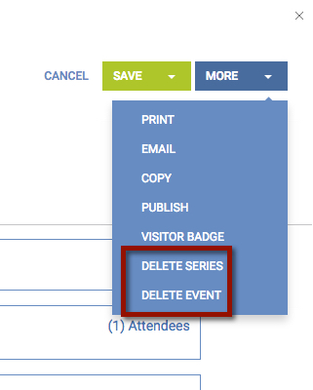

Managing Conflicts:
- If a room is unavailable for one of the days in your recurring pattern, you will be prompted to resolve the conflict. 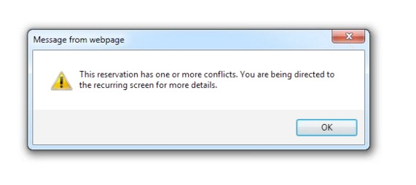
- Reservations with a conflict are marked in red. 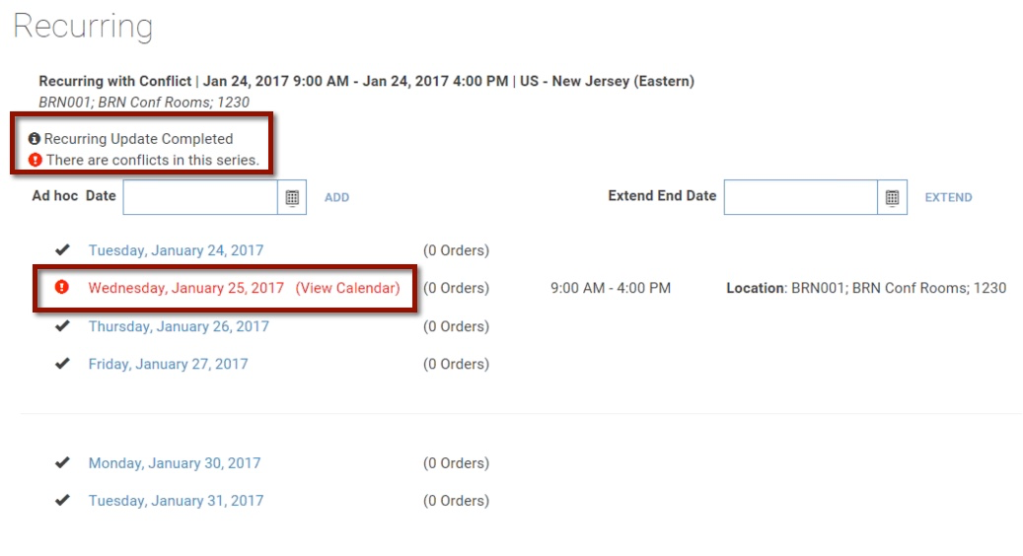
- Select the instance which is unavailable, and click on the meeting date.
- From the Reservation Details page, click on the Add Resources button. For recurring reservations, change only one instance at a time. 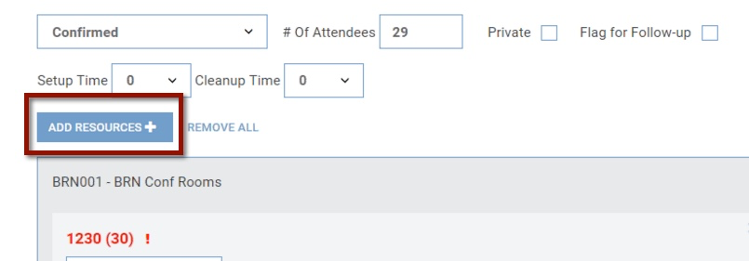
- Choose the group of rooms to search and click Show. A list of available rooms is shown. Select an alternate room for this instance of your recurring meeting, and click Submit.
- Click the X for the room highlighted in red to remove the conflict. 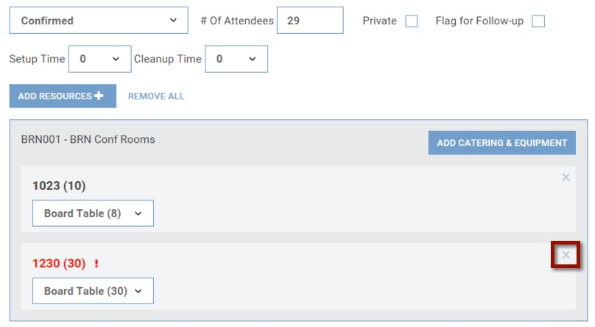
- Click Save to save your change. Choose Only This Event. 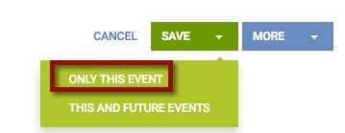

Requesting Equipment
Catering, A/V and IT equipment can be requested alone or along with a room reservation. If this is an independent request (with no associated room reservation), click the Catering & Equipment link in the Quick Links in the tool bar. To be included with a room reservation, click the Catering & Equipment button in the Reservation Details page.
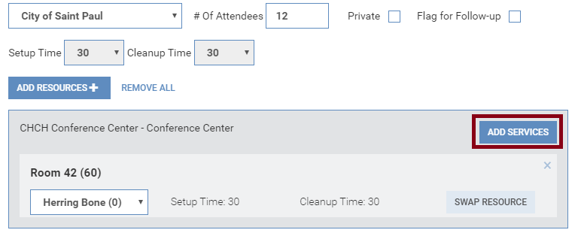
- Select the Add Service button for the needed service. The options will vary by location. If multiple rooms are reserved, confirm that the correct location is selected.
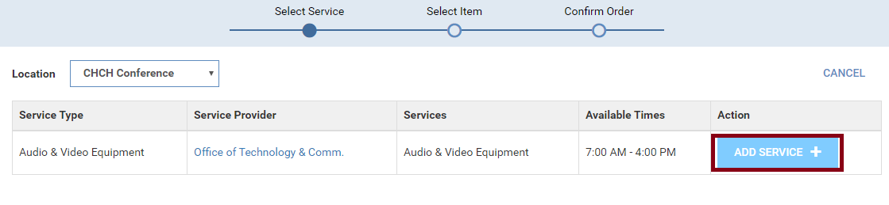
Note: Room 40 has the option to add a divider to split the room in half.
- The meeting title, date, times and location are automatically filled out if the request is part of a room reservation. The times can be adjusted if they should be different than the reservation (common for all-day meetings with catering needs).
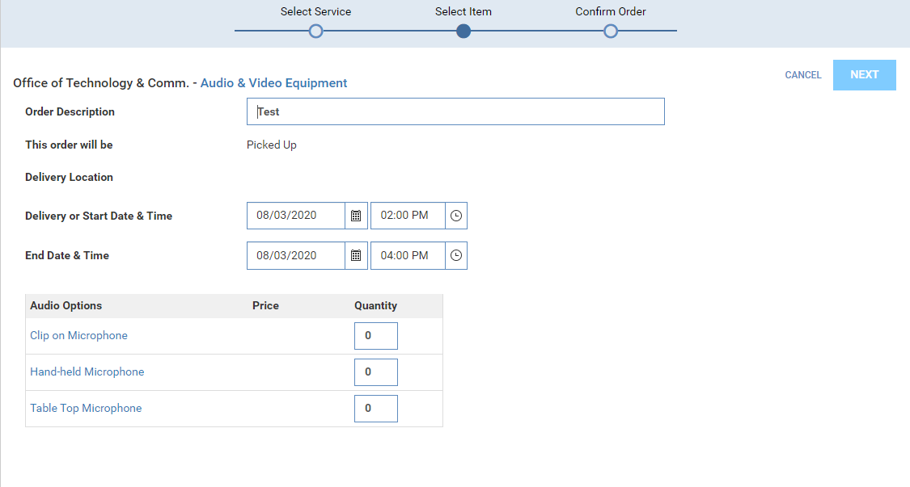
- Click on an Item’s Title to learn more about an item. Type the number needed for each desired item in the field next to its name.

- Click Next.
- In the Confirmation Page, type general information about the order in the Notes field in the top section.
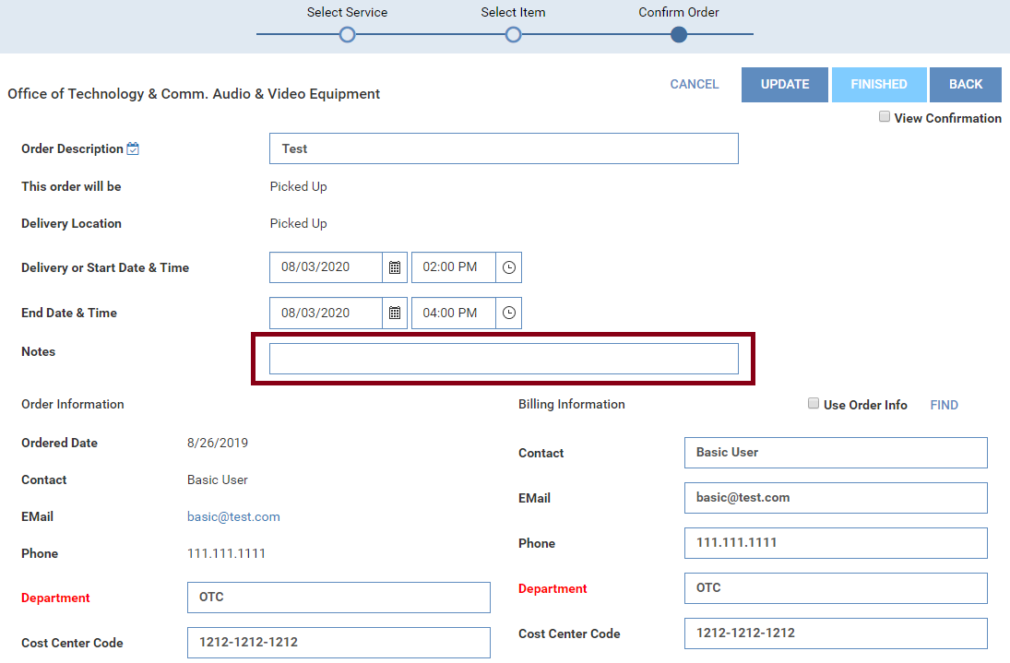

- The way the system is set up is that it will show invoices and prices when ordering items via services. Fortunately, the City does not charge for any of the services we are currently providing (microphones).
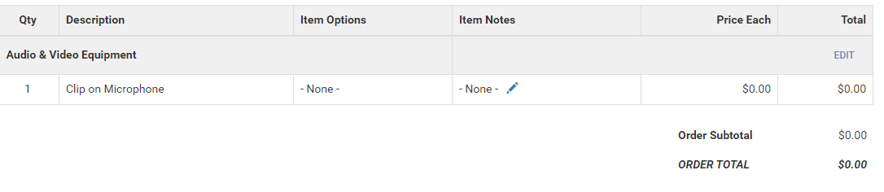
- Click Finished when done. Check the View Confirmation checkbox first if a printed confirmation is needed.
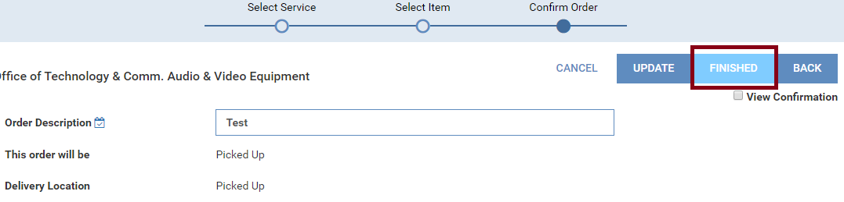
- The order now appears in the Reservation Details page. Click the Edit button to make changes to this request. To create further requests, click the Add Services button again.
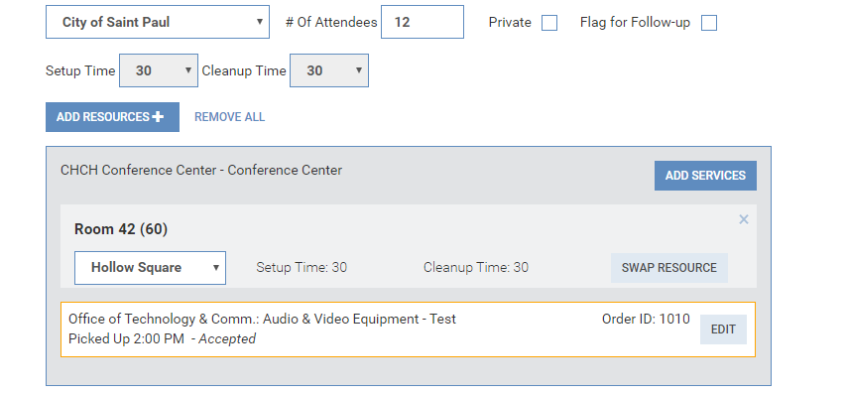

Adding More Information to a Reservation

Flagging a Reservation for Follow Up
Reservations can be flagged for tracking purposes if there will be additional changes to the information. In the Reservation Details page, check the box labeled Flag for Follow-up. Flagged reservations can be listed by clicking the More link under My Reservations.
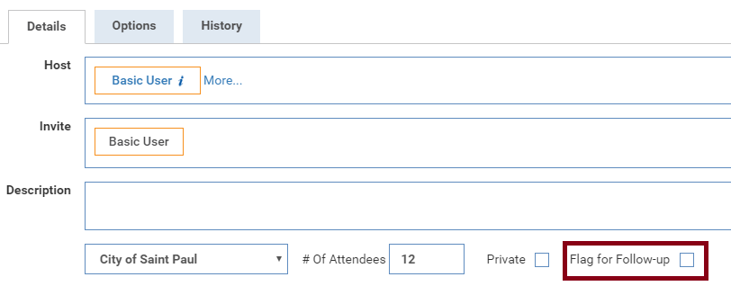

On Behalf Of:
If you are creating this reservation on behalf of someone else, click the More link in the Host section of the Reservation Details page.
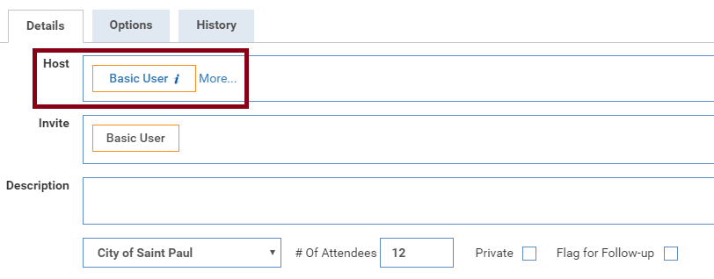

Enter or select the meeting host, and if needed a third party who is requesting the meeting. If the host is a Resource Scheduler user, you can search for their information with one of the links. They will receive email confirmations, reminders and notice of any changes if you keep the boxes checked.
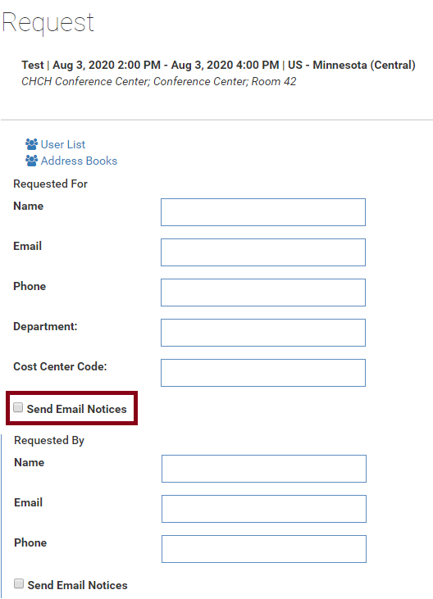

Other Features

Reports
The Reports link is available to some users in the Tool Bar at the top of the page. The following tips will help when using the standard reports:
- The Report Type drop-down displays categories of reports. Commonly used reports are frequently found in the Activities and Details, Managed Services and Resource Utilization sections.
- You can choose easy Time Ranges with the top radio button, or chose a Custom Time Range with the bottom one.
- Using the Scope, the report can be limited to a single room, group of rooms or location.
- Under Report Details, many reports will have a text description and picture of the page format. The Mark Report as Favorite will allow you to identify favorite reports you can name as desired. A favorite report will appear at the top the next time you visit the Reports page, and usually maintains the selected Time Range, Scope and Report Format that were set when the report was marked as a favorite.
- Some reports will include other filters under the Additional Criteria section.

Setting Personal Defaults
Your personal options allow you to chance your preferences such as default location, language and country.
- To change personal options, click on your name on the upper right hand corner of the screen and select My Information.
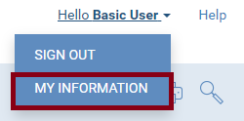
- If necessary, you can adjust the language displayed and which countries are displayed in the calendar view. Use the Language and Holiday drop-down boxes at the top of the page.
- Use the drop down lists to choose your home location under Default Location and Default Group.
- The Default Calendar View sets your preference for which calendar view is shown. You may choose Daily, Weekly or Monthly.
- Time Format choices will show the calendar in an AM/PM format or in 24-hour format.
- To be reminded of the End of Recurring Reservations, check that box. You can designate the minimum number of reservations that must be in the series before you are notified and at what point (number of remaining occurrences) the reminder should be sent.
- Click the Submit button to save your choices.

